# 

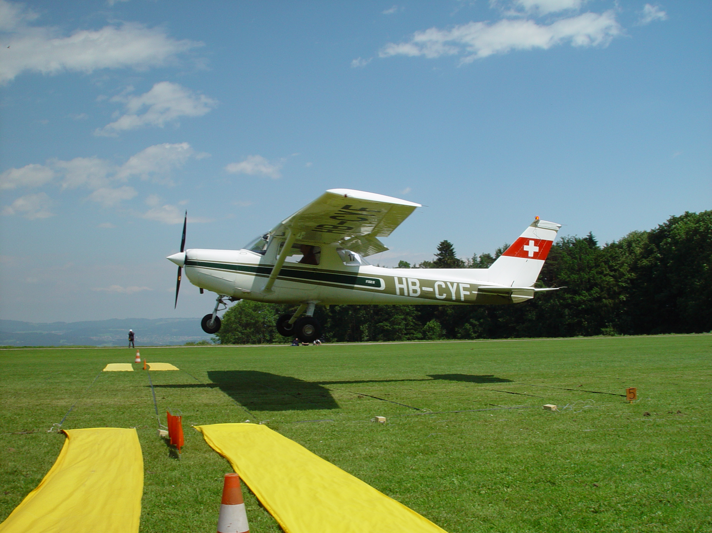

# Air Navigation Race Live

# User Manual

# 

# Document Information



|  |  |  |  |
| --- | --- | --- | --- |
| **Version** | **Author** | **Date** | **Comments** |
| 1.12 | Luca Selinger | 17.02.2010 | Translated to English |
| 1.13 | Luca Selinger | 19.02.2010 | Corrections and Updates. |
| 1.2 | Luca Selinger | 19.03.2010 | Corrections and Visualisation Description |
| 1.3 | Luc Baumann | 11.04.2010 | Review and minor corrections |

# Content

Air Navigation Race Live 1

User Manual 1

Document Information 2

Content 3

Index of Pictures 4

General Information 5

Scope of delivery: 5

Preparation 5

Tracker 6

Configuration of your tracker 6

Setting up your client 11

Requirements 11

Installing AirNavigationRaceLive 11

The “Credits And Developer” Tab 11

The “Connect To Server” Tab 11

Configure Trackers 12

Configure Races and Pilots 12

Creating a new race 12

Add a Pilot 12

Visualization Control 13

Air Navigation Race Live Support 14

# Index of Pictures

Abb. 1 Google Earth Plug In 5

Abb. 2 GPS Tracker Device configuration 6

Abb. 3 TR Management Center 7

Abb. 4 Scan COM Port 7

Abb. 5 found COM Port 8

Abb. 6 Setup 8

Abb. 7 Basic Setup 9

Abb. 8 GPRS Setup 10

Abb. 11 Open New issue 14

# General Information

## Scope of delivery:

1 User Manual, 1 GPS- Tracker, 1 CD-ROM, 1 Power supply, 1 Akku, 1 USB- Cable.

SIM-Cards are not included.

## Preparation

In order to make the Air Navigation Race Live Software work, you first have to install **Google Earth Plug-In** in the **Internet Explorer (Firefox won’t work)**.

You can find it following this link: <http://code.google.com/intl/de-CH/apis/earth/> (s.Abb.1)

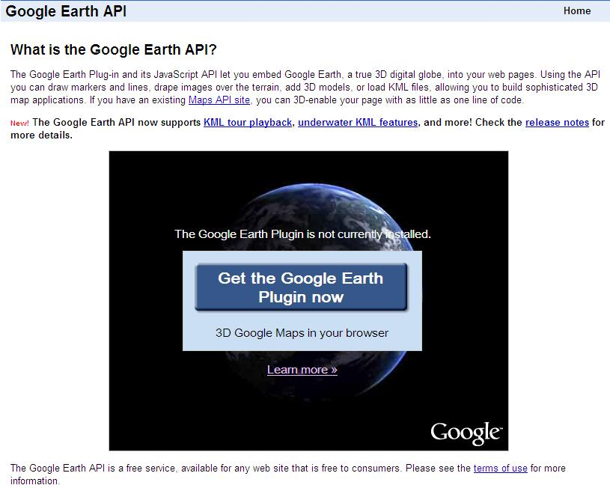

Abb. 1 Google Earth Plug In

# Tracker

Install the provided Tracker-Software.

Insert the CD into your CD-Drive and start it. Follow the Instructions on the Screen.

## Configuration of your tracker

After successfully installing the Tracker-Software you may plug the provided USB-Cable to your Computer.

Open up the GPS-Tracker and insert your SIM-Card.

In order to Configure your GPS-Tracker, you need to switch the **Pin Nr. 3** ON. (s. Abb2).

Your tracker is now in **SETUP-MODE** and may now be configured by your computer.

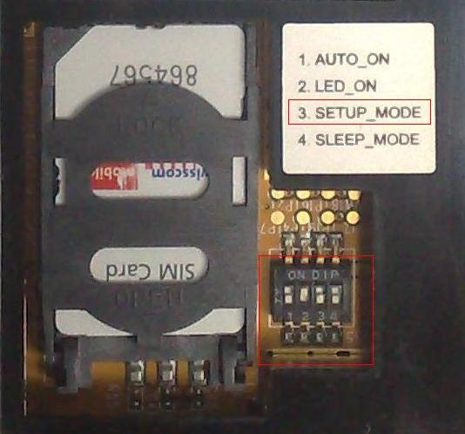

Abb. GPS Tracker Device configuration

Now you need to plug your Tracker to your computer, using the USB-Cable.

You may now start the Tracker-Software.

As soon as you start the Tracker-Software, the “**TR Management Center**” will open.

To configure your tracker, choose **TR-151 Setup** from the menu-bar. (as seen in Abb.3)

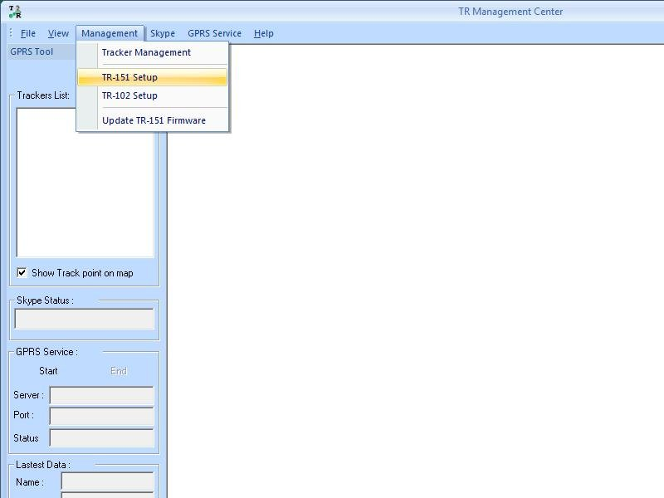

Abb. TR Management Center

Press the Button **Scan COM Port** (as seen in. Abb.4).

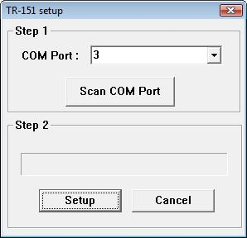

Abb. Scan COM Port

The Tracker-Software is now automatically checking all your ports for connected Trackers.(as seen in Abb5)

The Software shows a message box, showing you at which port it found a connected tracker. (For example **COM Port 4 find**, means it found a tracker at port 4)

Press “ok”.

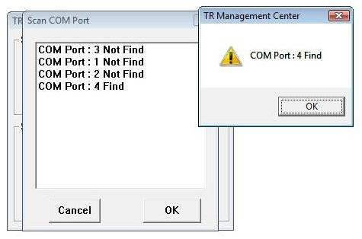

Abb. found COM Port

Now choose the previously found port from the DropDown-menu at „Step1“

After you chose the right one, press the Button “**Setup**” at “Step 2” (as seen on Abb. 6)

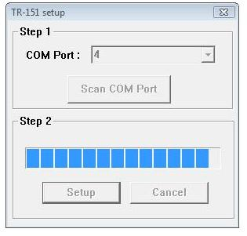

Abb. Setup

A new window appears (as seen in Pic 7).

Now choose the Tab **Basic Setup**.

Enter the telephone number of your SIM-Card. You can as well enter a **Tracker name**.

Set the **Maximum GPS fixing time**. This number sets the time span for the tracker to find his position.

With the **Report interval** you can set the interval in which the tracker will send its data. We recommend a time span of 5 to 10 seconds. The Default report mode need to be “GPRS Period Report”.

|  |  |
| --- | --- |
| **!** | **Important Information:** Please take note of your **IMEI Code** number. This is a unique number. If you have more than one device you need to know which number belongs to which tracker. A good idea is to write the number on the tracker. You need that number later in order to **add a pilot to a tracker**. |

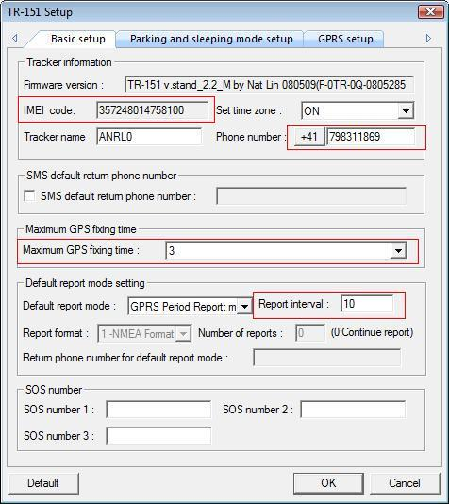

Abb. 7 Basic Setup

Now choose the tab **GPRS-Setup**. Fill in the red-framed fields as seen in the picture (Nr. 8).

**Important:** These values have to be correct!

The GPRS Server has to be adjusted to your Server running the Service of ANRL.

**For a Swisscom-Abo and our Server you need to use the following values:**

|  |  |
| --- | --- |
| GPRS user name | Gprs |
| GPRS user password | Gprs |
| GPRS apn | gprs.swisscom.ch |
| GPRS_dns1 | 164.128.36.34 |
| GPRS_dns2 | 164.128.76.39 |
| GPRS Server IP address or Domain name | **83.169.11.154** |

Note that the Server-Address changed; use the one in the table and not the one from the Screenshot.

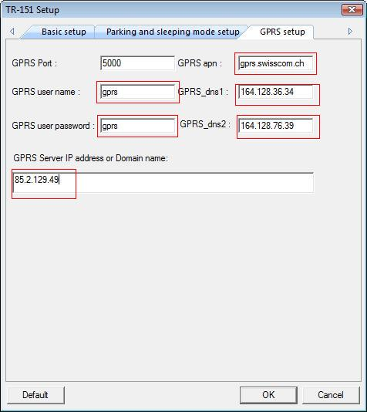

Abb. 8 GPRS Setup

After you are done, press OK. Your values will be saved automatically and a pop-up appears, that informs you that the entries were successfully saved.

Finally press **End**.

Now all you need to do, is to cancel the setup mode of the tracker. You do this by setting the **PIN Nr3** on your device back to OFF.(Pic Nr.2).

# Setting up your client

## Requirements

* .Net Framework 4.0
* Internet Connection
* Port 5555 has to be open
* Google Earth Plug-In installed

## Installing AirNavigationRaceLive

Visit the Google Code Page of AirNavigationRaceLive at:

<http://code.google.com/p/anrl/downloads/list>

There you can find two versions of ANRL. It is recommended to use the **ANRL-Online-Starter.exe** since this version will always use the newest version.

If you download the **ANRL-Online-Starter.exe** the program will start after some seconds.

## The “Credits And Developer” Tab

On this tab you will find the programmers of AirNavigationRaceLive.

If you like this program and want to support its developers, you may use the button on the lower right to donate via pay pal.

## The “Connect To Server” Tab

On this tab you can connect to the **ANRL-Server**. Choose 127.0.0.1:5555 if you are running a local ANRL-Server. Else choose the other one.

Enter your **username** and **password** and press the **Connect-Button**.

In the status bar you find information about the connection-process.

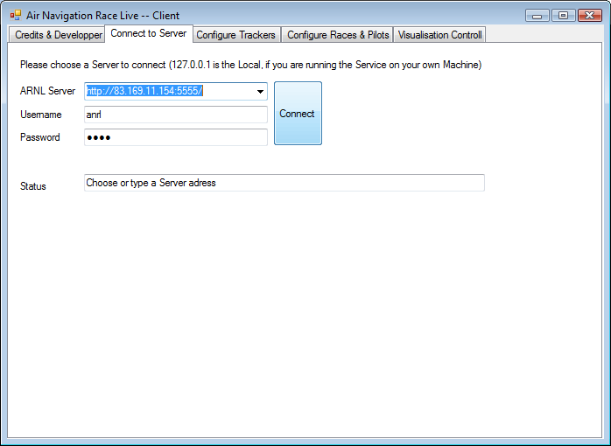

## Configure Trackers

As soon as you are connected to the server, the view will change to **“Configure Tracker” –Tab**.

In this window you can view a **list of all trackers** the server knows. You may also add a pilot to a tracker or remove a pilot from a tracker.

In order to add a pilot to a tracker, you have to create a pilot first.

To add a pilot and create a races, use the tab **“Configure Races & Pilots”**.

## Configure Races and Pilots

### Creating a new race

To create a new race press the button “**New**”. Enter a **race-name**, a **date**, **starting-time and duration**.

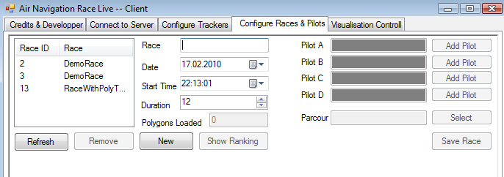

It is very important that you add a **parcour**. A parcour can be imported from a **.dxf file** or chosen from a list of already available parcours. The parcours will set the **penalty zones** in ANRL.

If you are done with adding pilots and choosing the settings for your race, press “**Save Race**” and after hitting the **refresh button** on the left, you will see your new race.

### Add a Pilot

Now you can add pilots to the race. **Pilots are limited to 4 for each race**. Press “**Add Pilot**” and a new window will appear in which the server provides you with the already existing Pilots.

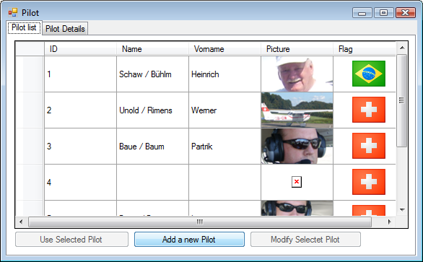

Now you get to choose from 3 different choices.

1. You can use an existing pilot (if he/she is available on the server). You do this by selecting the “**Name**” of the pilot you want to select and press the button “**Use Selected Pilot**”.  
   The selected pilot is now added to your race.
2. If you want to add a new pilot press the “**Add a new Pilot**”-button.   
   Now you can give your pilot a **lastname** and **surename** and choose a **color** for your Pilot.  
   The server provides you with a collection of flags. So choose your **national flag** by clicking on the **nation’s name**.   
   You can as well add a picture. This one needs to be 100x100 px.  
   If you are done, press “**Save Pilot**”.

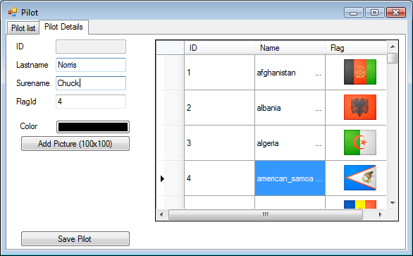

1. If you just want to edit an existing pilot choose “**Modify Pilot**”

## Visualization Control

This Tab allows you to Control the Google Earth Visualisation. Here’s a step-by-step description on how to start and setup the visualisation.

1. Once you have created a race and added pilots, you can start the Visualisation by pressing “**Start Visualisation**”. The Google Eart Plug-In is now loading, please wait for a few seconds.
2. When it is loaded you will see the earth. Now you can click the checkbox near the race, you want to show and the Penaltyzones and Starting /Endinglines will be painted.
3. To zoom in, double click the location where the race is at.
4. Next you may choose which pilots you want to show, by either checking or unchecking the Checkbox next to their Names.
5. If you want a ranking to be displayed, you can now click on “**Show Ranking**”.
6. Now you either set the delay to a date and time when the race is happening and press the “**apply delay**”-button right under the date, or you press the “**get delay**”-button and choose a delay from the list and press “**apply delay**”.
7. The race will now start from the selected delay.
8. While the race is running, you can adjust some settings.  
   You can change the thickness of the lines, adjust the penalty-zone height and if the race is already recorded on the server, you can change the speedtime.  
   The scrollbar on the bottom allows you to fast forward, if the server has newer data than you’re watching. Or you can aswell use the “**show newest entry**” checkbox and you will always have the newest entry, the server sends you.
9. If you’re playing a recorded race and you want to (re)start the race at a specified time, you can choose the delay from the drop down, or you can change the time, to the time your race was recorded. By pressing “**apply delay**” the race will start to paint from the selected time and date.

**Note:** Ranking can only be started if you have selected a race.

If you reset the delay time, the ranking will **not** reset. To reset the ranking you need to close the ranking window and reopen it.

# Air Navigation Race Live Support

Support is handled by opening e new Issue at <http://code.google.com/p/anrl/> (Pic Nr. 11).

You need an Email address at Google to log in.

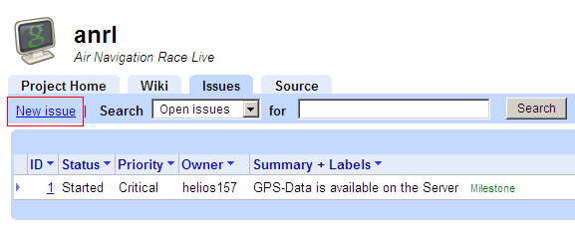

Abb. Open New issue